CVGRC Newsletter
October 2024


This Photo by Unknown Author is licensed under CC BY-SA


RECENT MEETING

A BIG THANK YOU to Cindy Hazelett for talking about the process of getting a dog certified as a Therapy dog and the surprising number of facilities that welcome therapy dogs.

Nominating Committee:
President: Steve Harmon
V.P. Sue Sanvido
Recording Sec. Vicki White
Corresponding Sec. Kathy Koenig
Treasurer. Tara Perby

Board
Holly Tolley
Donna Edwards

NEXT MEETING 

Sunday, November 3, 2:00 pm (please note time)
Wolfe Creek Winery
2637 S. Cleveland Massillon Rd., Norton, Ohio 44203

Dogs are welcome!!
Scavenger Hunt and Costume Contest for both the dogs and their person whom they bring along!
Congratulations to Ann Lynn and her dogs!

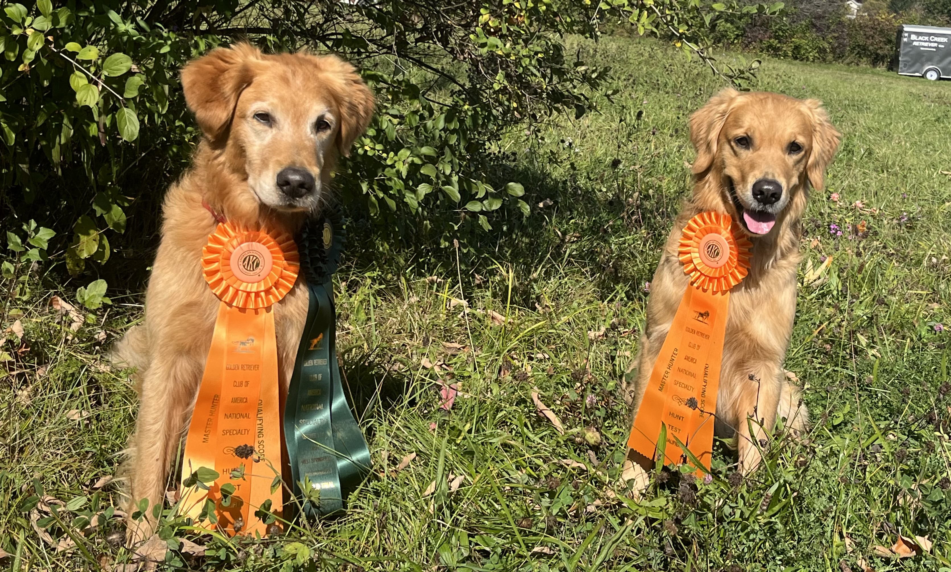
Ann Lynn participated in the field trial and hunt test at the GRCA Nationals in Sprakers, NY. Her 9.5 year old Spock (Emeline’s One Hot Vulcan ** CDX MH23 WCX CCA VC) earned a Judge’s Award of Merit (JAM) in the Qualifying stake at the field trial. This is the first field trial ribbon she’s ever earned.
At the Master stake, both Spock and her young dog Trek (Audeo’s Warp Speed WCX) earned Master passes. This was Trek’s second Master test. He has passed both tests he entered.
Her dogs are 100% owner trained and handled.

UPCOMING EVENTS
November
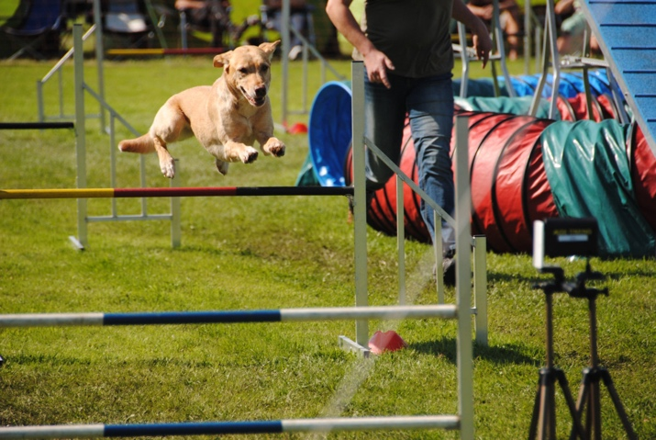
Nov 15th, 16th, 17th CVGRC Agility Trial

Requesting additional members to help. Please contact Karen Groth if you can volunteer.

Thank you in advance!

Karen Groth
CVGRC Trial Chair
@PDS Agility

December
We will be having a Christmas Gathering at Santa Soussas in Medina. We will be celebrating our Club Members at this event so please plan on attending! This will be our last in person meeting until Spring. Please keep an eye out for more information to come on that.

Please Send All Newsletter announcements to holltoll@hotmail.com

President
Amy Harmon
Vice President
Vicki White
Treasurer
Tara Perby
Corresponding Secretary
Kathy Koenig
Recording Secretary
Steve Harmon

