CUYAHOGA VALLEY
GOLDEN RETRIEVER CLUB, INC.

WC/WCX TEST

Date: Sunday September 3, 2017
Time: WCX judging begins at 9:00 AM
WC will follow the WCX

Judges: Jan Masica and Terri Pardee

Location: Hambden Nursery, Chardon, OH

Birds: Ducks

Entry Fees: WC - $40.00 WCX - $45.00

ENTRIES CLOSE AT 8:00 PM EDT on Friday, August 25, 2017
PLEASE USE ATTACHED OFFICIAL G.R.C.A. ENTRY FORM FOR ENTRIES!
NO POST ENTRIES, Fax or email entries accepted
Make check payable to C.V.G.R.C. and mail with completed entry form to:
Tara Perby
10620 Locust Grove Dr.
Chardon, Ohio 44024
440-286-5744, xroadsglds@aol.com

The GRCA Board is now requiring entries in the WC/WCX to send a copy of the dog’s AKC/CKC registration with the entry form.

The tests will be run under AKC Field Trial Rules as modified by G. R. C. A.
Winger use in the WCX is permitted and may be used.
Qualifying dogs will receive certificates and rosettes.

BITCHES IN SEASON ARE NOT PERMITTED ON THE TRIAL GROUNDS.

Chair: Kathy Koenig
Committee: Tara Perby, Carol Young, Christy Thomas, Vonnie Peterson

These tests are open to all AKC retrievers. Goldens and Flat-Coats will run before all other breeds. Entries are limited to 40 dogs with preference to untitled Goldens.
Please bring any official rules for your specific breed Club and any forms that need to be signed by the judges.
Bring food and water for your dogs.

Lunch will be provided compliments of CVGRC
Bring a side dish if you want
Donations gratefully accepted

Scratches: Full refund will be made for sickness, injury, death, or bitches in
season upon receiving a note from a veterinarian. Others as follows: Before the draw, full refund. After the draw and before the start of the test, refund less $5.00. After the start of the test, no refund.

DIRECTIONS

Headquarters and WC/WCX tests are located at Hambden Nursery, PLEASE note there is a new entrance to the grounds. The new entrance is a gravel driveway next to 9131 Kile Rd. Chardon OH. Take Rte 6E and make a left on Kile.
MAP TO HAMBDEN NURSERY
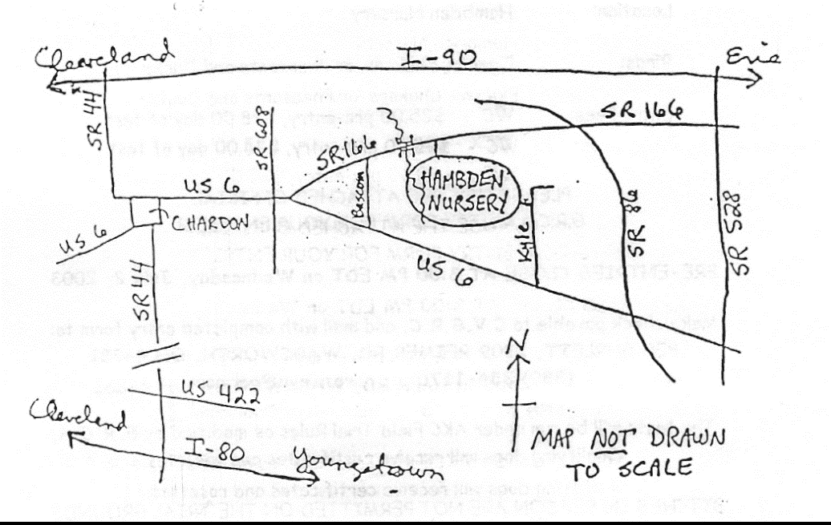

MOTELS IN THE AREA

Red Roof Inn I-90 at SR 306 Willoughby, OH (440) 946-9872
Motel 6 I-90 at SR 306 Mentor, OH (440) 953-8835
Super 8 Mentor SR 306 at SR 2 Mentor, OH (440) 951-8558
Studio 6 SR 306 at SR 2 Mentor, OH (440) 946-0749
Comfort Inn I-90 at SR 45 Austinburg Twp., OH (440) 275-2711
Travelodge I-90 at SR 45 Austinburg Twp., OH (440) 275-2011
Howard Johnson’s I-90 at SR 534 Geneva, OH 440) 466-1168

Golden Retriever Club of America, Inc.
Official WC/WCX Test Entry Form

Test Giving Club: Cuyahoga Valley Golden Retriever Club, Inc.
Date: Sunday September 3, 2017
Location: Hambden Nursery, Hambden, Ohio
Entries Close: 8 PM EDT, Friday, August 25, 2017
Entry Fees: WC = $40.00 WCX = $45.00
Make Checks Payable to: C.V.G.R.C., Inc.
(Canadian Checks should be made payable in U.S. funds)
Mail Entries to: Tara Perby 10620 Locust Grove Dr. Chardon, Ohio 44024
Phone: (440) 286-5744 e-mail: xroadsglds@aol.com

I enclose $_________for entry fees. CALL NAME_____________________
Entry for: _________ WC test ___________ WCX test ________________

DOG’S REGISTERED NAME
BREED |  | SEX
ENTER NUMBER HERE  ___AKC REG NO.  ___AKC LITTER NO.  ___ILP NO.  ___FOREIGN REG NO. & COUNTRY | DATE OF BIRTH
PLACE OF BIRTH
___USA ___CANADA___FOREIGN
BREEDER
SIRE
DAM
ACTUAL
OWNER(S)
OWNER’S
ADDRESS
CITY, STATE, ZIP
HANDLER
I agree that the dog named herein is entered in and will be in the test at my own risk and that I will hold the host club, its members and agents, free from liability for any claims arising out of the entry of the dog or its presence at the test.
SIGNATURE
PHONE EMAIL
FOR CLUB/JUDGES’ USE ONLY
NO. | JUDGE
PASSED/FAILED | JUDGE

